22k-5195 lab 5

Task1:

public class Task1 {  
 public static void main(String[] args) {  
 int result = *sum*(5, 10);  
 System.*out*.println("The sum of numbers between 5 and 10 is : " + result);  
 }  
  
 public static int sum(int start, int end) {  
 if (start > end) {  
 return 0;  
 }  
 else {  
 return start + *sum*(start + 1, end);  
 }  
 }  
}

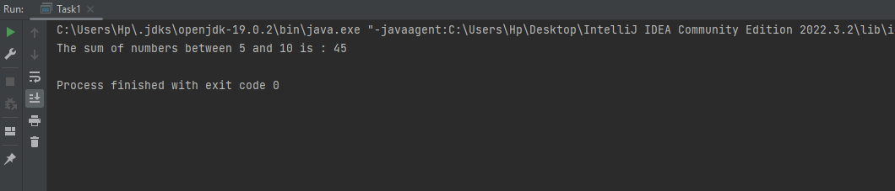

Task 2a:

public class Task2a {  
 public static int arithmeticSequence(int n) {  
 if (n == 1) {  
 return 1;  
 }  
 else {  
 return n + *arithmeticSequence*(n - 1);  
 }  
 }  
  
 public static void main(String[] args) {  
 int terms = 7;  
  
  
 System.*out*.println("The arithmetic sequence is: ");  
 for (int i = 1; i <= terms; i++) {  
 System.*out*.println( *arithmeticSequence*(i));  
 }  
 }  
}

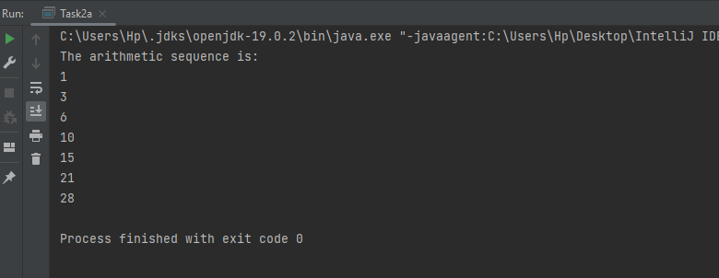

Task 2b:

public class Task2b {  
 public static void main(String[] args) {  
 int n = 13;  
  
 System.*out*.println("The fibonacci series is: ");  
  
 for (int i = 0; i < n; i++) {  
 System.*out*.print(*fibonacci*(i) + " ");  
 }  
 }  
  
 public static int fibonacci(int n) {  
 if (n <= 1) {  
 return n;  
 }  
 else {  
 return *fibonacci*(n - 1) + *fibonacci*(n - 2);  
 }  
 }  
}

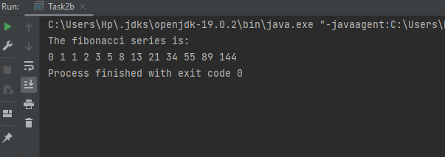

Task 2:

import java.util.Scanner;  
  
public class Task2 {  
 public static void main(String[] args) {  
 Scanner a = new Scanner(System.*in*);  
 System.*out*.println("Start of range:");  
 int start = a.nextInt();  
 System.*out*.println("End of range:");  
 int end = a.nextInt();  
  
 System.*out*.println("Composite numbers in the given range " + start + " to " + end + ":");  
 *Composites*(start, end);  
 System.*out*.println();  
 System.*out*.println("Prime numbers in the givenrange " + start + " to " + end + ":");  
 *Primes*(start, end);  
 }  
  
 public static void Composites(int start, int end) {  
 if (start > end) {  
 return;  
 }  
  
 if (*isComposite*(start)) {  
 System.*out*.print(start + " ");  
 }  
  
 *Composites*(start + 1, end);  
 }  
  
 public static boolean isComposite(int n) {  
 if (n <= 1) {  
 return false;  
 }  
  
 for (int i = 2; i <= Math.*sqrt*(n); i++) {  
 if (n % i == 0) {  
 return true;  
 }  
 }  
  
 return false;  
 }  
 public static void Primes(int start, int end) {  
 if (start > end) {  
 return;  
 }  
  
 if (*isPrime*(start)) {  
 System.*out*.print(start + " ");  
 }  
  
 *Primes*(start + 1, end);  
 }  
  
  
  
 public static boolean isPrime(int n) {  
 if (n <= 1) {  
 return false;  
 }  
  
 for (int i = 2; i <= Math.*sqrt*(n); i++) {  
 if (n % i == 0) {  
 return false;  
 }  
 }  
  
 return true;  
 }  
}

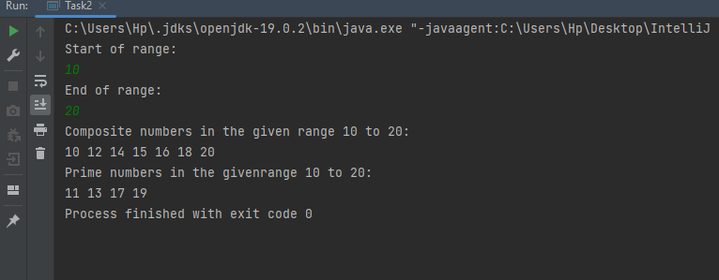

Task 3:

import java.util.Scanner;  
  
public class Task3 {  
 public static void main(String[] args) {  
 Scanner a = new Scanner(System.*in*);  
  
 String input ;  
  
 System.*out*.println("Enter a string value:");  
  
 input = a.nextLine();  
  
 String reverse = *reverseString*(input);  
  
  
 if (input.equals(reverse)) {  
 System.*out*.println("PALINDROME");  
 }  
 else {  
 System.*out*.println("NOT PALINDROME");  
 }  
 }  
  
 public static String reverseString(String str) {  
 char[] charArray = str.toCharArray();  
 int start = 0;  
 int end = charArray.length - 1;  
  
 while (start < end) {  
  
 char temp = charArray[start];  
 charArray[start] = charArray[end];  
 charArray[end] = temp;  
  
 start++;  
 end--;  
 }  
  
 return new String(charArray);  
 }  
}

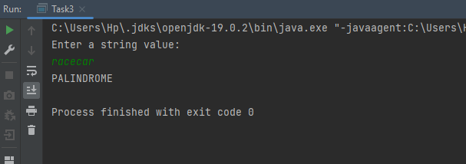

Task 4:

public class Task4 {  
 public static void main(String[] args) {  
  
  
 int[] arr = {1, 2, 3, 4, 5};  
 boolean isSorted = *isSortedArray*(arr, arr.length);  
  
 for(int i=0; i<arr.length;i++){  
 System.*out*.println(arr[i]);  
 }  
  
 if (isSorted) {  
  
 System.*out*.println("The array is sorted.");  
 } else {  
 System.*out*.println("The array is not sorted.");  
 }  
 }  
  
 public static boolean isSortedArray(int[] arr, int n) {  
  
 if (n <= 1) {  
 return true;  
 }  
  
 if (arr[n - 1] < arr[n - 2]) {  
 return false;  
 }  
 return *isSortedArray*(arr, n - 1);  
 }  
}

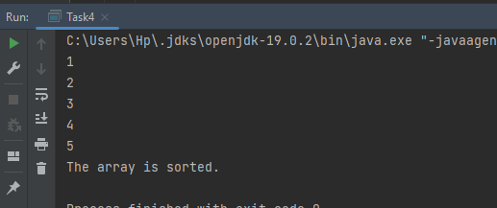

Task 5:

import java.util.ArrayList;  
import java.util.List;  
  
public class Task5 {  
 public static void main(String[] args) {  
 int[] nums = {1, 2, 3, 4};  
   
 int targetSum = 7;  
   
 List<List<Integer>> subsets = *findSubsetsWithSum*(nums, targetSum);  
  
 if (subsets.isEmpty()) {  
 System.*out*.println("No subsets found with the target sum.");  
 } else {  
 System.*out*.println("Subsets with the target sum:");  
 for (List<Integer> subset : subsets) {  
 System.*out*.println(subset);  
 }  
 }  
 }  
  
 public static List<List<Integer>> findSubsetsWithSum(int[] nums, int targetSum) {  
 List<List<Integer>> result = new ArrayList<>();  
 *findSubsets*(nums, targetSum, new ArrayList<>(), 0, result);  
 return result;  
 }  
  
 public static void findSubsets(int[] nums, int target, List<Integer> current, int index, List<List<Integer>> result) {  
 if (target == 0) {  
 result.add(new ArrayList<>(current));  
 return;  
 }  
 if (index >= nums.length || target < 0) {  
 return;  
 }  
   
 current.add(nums[index]);  
 *findSubsets*(nums, target - nums[index], current, index + 1, result);  
   
 current.remove(current.size() - 1);  
 *findSubsets*(nums, target, current, index + 1, result);  
 }

